Key Indicator 3.2- Research Publication and Awards (15)
Metric  No. |  | Weightage
3.2.2.  Q_{n}M | Number of books and chapters in edited volumes/books published and papers published in national/ international conference proceedings per teacher during last five years  3.2.2.1. Total number of books and chapters in edited volumes/books published and papers in national/ international conference proceedings year wise during last five years  Formula:  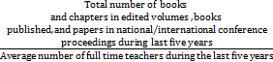  File Description: (Upload) | 10
  Year | 2020-21 | 2019-20 | 2018-19 | 2017-18 | 2016-17
  Number | 19 | 08 | 05 | 73 | 07

